[Web Dev Toolkit] Project Plan

April Ferris

WDD 131

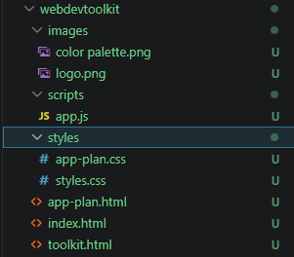

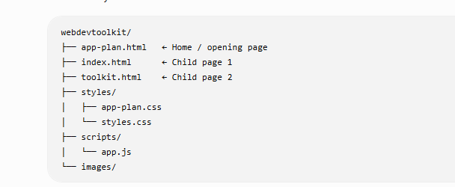

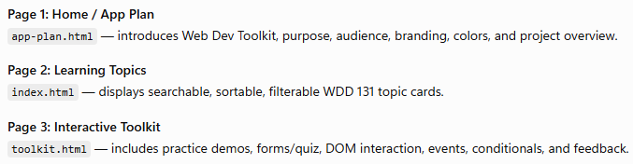

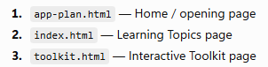

Purpose

The purpose of Web Dev Toolkit is to help beginner web development students review and practice the major skills taught in WDD 131. The site will organize HTML, CSS, JavaScript, accessibility, responsive design, forms, arrays, objects, sorting, and filtering into one interactive learning platform.

Audience

The audience for this website is beginner web development students who are learning how to build valid, responsive, accessible, and interactive websites. The site is designed for students who need simple explanations, visual examples, and practice tools to help them understand class concepts.

Dynamic elements
JavaScript will be used to create interactive learning features throughout the site. The home page will display topic cards from an array of objects. Each object will include a topic title, category, difficulty level, description, and image.
Users will be able to search for topics, filter topics by category, and sort topics alphabetically or by difficulty level. JavaScript will also be used for DOM interaction, including updating the displayed cards, showing a “no results found” message, opening and closing navigation, and responding to user events.
The toolkit page will include interactive examples where users can click buttons, submit a form, answer a quick question, and see feedback on the page. Conditional logic will be used to check user choices and display different messages depending on the result.

Branding
Website Logo
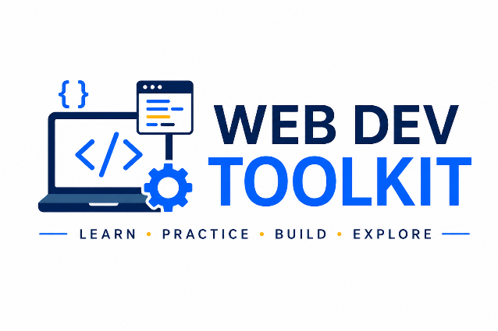

Style Guide
Color Palette

Palette URL: https://coolors.co/f7f8fa-ffffff-1f3a5f-4a6fa5-f4b942-2d3748-d9e2ec
Primary- Deep Navy- | Secondary -Steel Blue | Accent 1-Warm Gold | Accent 2-Soft Light Gra
[#1F3A5F] | [#4A6FA5] | [#F4B942] | [#D9E2EC]
Pseudocode for your project
When the website loads:
- Load the page.
- Load the array of web development topics.
- Create topic cards from the array of objects.
- Display all topic cards on the home page.
- Display the featured topic.

Navigation
- Wait for the user to click a navigation link.
- If Home is selected, display the Home page.
- If Toolkit is selected, display the Toolkit page.
- Highlight the active navigation item.

Search
- Wait for the user to type in the search box.
- Compare the search text to each topic title.
- Display only matching topic cards.
- If no topics match, display a "No Topics Found" message.

Filter
- Wait for the user to choose a category.
- If "All" is selected, display every topic.
- Otherwise, display only the topics in the selected category.
- Update the topic cards on the page.

Sort
- Wait for the user to choose a sorting option.
- If A–Z is selected, sort topics alphabetically.
- If Z–A is selected, reverse the alphabetical order.
- If Difficulty is selected, sort by difficulty level.
- Redisplay the topic cards.

Topic Cards
- Wait for the user to select a topic.
- Display additional information about the topic.
- Show an explanation.
- Show a code example.
- Show an interactive demonstration.

Interactive Examples
- Wait for the user to interact with the example.
- Detect button clicks or form input.
- Update the example using JavaScript.
- Display the results immediately.

Knowledge Check
- Wait for the user to answer a question.
- Check the selected answer.
- If the answer is correct:
  - Display a success message.
- Otherwise:
  - Display a message encouraging the user to try again.

Feedback Form
- Wait for the user to complete the form.
- Validate all required fields.
- If information is missing:
  - Display an error message.
- Otherwise:
  - Display a confirmation message.

Responsive Design
- Detect the screen size.
- If the screen is mobile:
  - Display the mobile layout.
- Otherwise:
  - Display the tablet or desktop layout.

Accessibility
- Display descriptive alt text for all images.
- Provide labels for all form controls.
- Allow keyboard navigation.
- Maintain sufficient color contrast throughout the website.
Wireframes
Create wireframes for your project page(s). One for each page and list them here.
Landing page
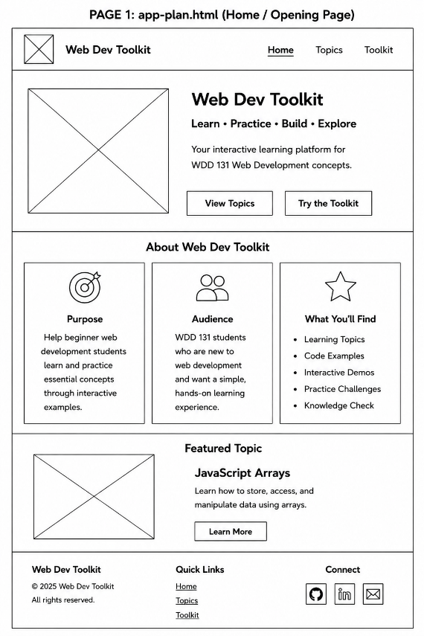
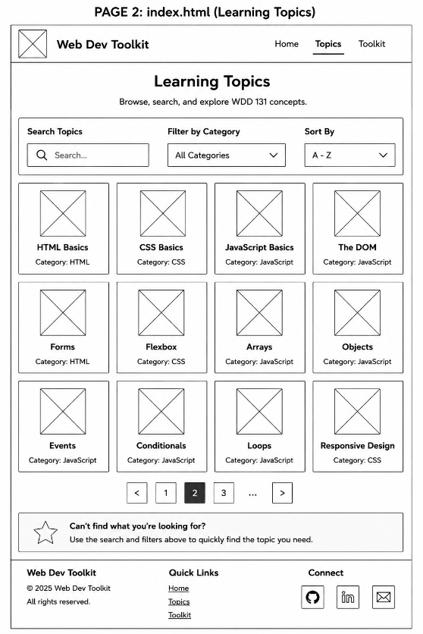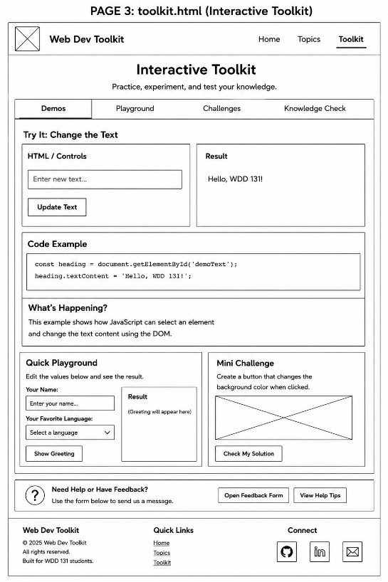
[Any additional details about home that the wireframe does not make clear]

[Page 2 if needed]
---------------All pages are given------------
[Any additional details about page 2 that the wireframe does not make clear]
none

